Educational Diversity

Academic Outcomes

Year 11 students

Year 2022/23

Contents
- Overview

- Our Performance Measures

- Measures of Engagement and Participation
  - Students entered for at least 1 qualification
  - Students entered for 5+ GCSEs or equivalent
  - Key Subject: Students entered for a qualification in English
  - Key Subject: Students entered for a qualification in Maths
  - Key Subjects -Percentage of pupils entering English and Mathematics GCSEs

- Measures of Attainment
  - Students gaining 1+ qualifications
  - Students gaining 5+ qualifications
  - Students gaining 5+ GCSE 1-9 Grades or equivalent
  - Higher GCSE Grades - 1+ GCSE 1-9 or equivalent
  - Higher GCSE Grades - 5+ GCSE 4-9 or equivalent
  - Higher GCSE Grades - 5+ 4-9 including English and Maths GCSE
  - English Baccalaureate
  - Key Subject: Any qualification in English
  - Key Subject: Higher grades in English – 4-9 or equivalent
  - Key Subject: Any qualification in Maths
  - Key Subject: Higher grades in Maths – 4-9 or equivalent
  - Key Subjects: 1-9 or equivalent in English and Maths
  - Key Subjects: Higher grades in English and Maths – GCSE grades 4-9.

- Comparison of 2019, 2020, 2021 and 2022 results

- Trends Over Time

- External Students
- Headlines
- Overview
Educational Diversity supports students who are unable to access mainstream provision as a result of social, emotional, behavioural or medical needs. As such, the cohort is constantly changing , the number of students on roll was 91 at the beginning of the academic year, through to 107 at the end of June 2023. A significant proportion of these students tend to be in KS4, often having arrived from Out of Area, with significant gaps in their education.
At the start of 2021/22, there were 39 learners in year 11, which subsequently increased to 50 by the end of the academic year which saw an increase of 28.2% in the year group.
Of the 50 students in year 11 (June 2023), 16 (32%) of these students joined part way through year 11, with 5 of these (10%) having only been with us only for a maximum of six months from January onwards.
For the purposes of analysis, all statistics refer to all 50 students who were on role of Educational Diversity at the end of the academic year. This includes both fully registered (28) and dual registered students (22).
As the majority of these learners arrive with little evidence of prior learning, together with disengagement,complexity of need and low attendance, the challenge is always to try to ensure they leave our school / service with some recognised qualifications. This is a priority and so we explore as many accreditation routes as possible, employing a number of strategies in an endeavour to ensure this happens. We appreciate that, for some students, attainment may be at a relatively low level but also recognise that by re-engaging in their own learning they can significantly enhance self-esteem and willingness to continue further post-16.

2. Our Performance Measures
We are aware that for mainstream schools the Progress 8 performance measures are used.
However, as PRUs are not included in these national calculations, we have chosen measures that best reflect the aims of the service.
This report therefore recognises two aspects:
- Year 11 students' re-engagement in education as measured by their participation in examination entries, especially key subjects that enhance employability
- Students' outcomes in terms of attainment in these examinations

For self-evaluation, this report also compares our figures against Alternative Provision (AP) settings nationally. Specific data from PRUs is not available.

We have used the 2019 national data, as DfE has not published more recent statistics.
Comparative data is taken from the DfE document:
DFE Education Statistics (2019)
JCQ Examination results (2021)

3. Measures of Engagement and Participation

- Students entered for at least 1 qualification
50 students were on roll in June 2023, all were entered for recognised qualifications.
This is in line with previous academic years
37 (74 %) of pupils were entered for 1+ GCSEs or equivalents.
This is an increase from 2021/22 when 50% of students were entered for 1+ GCSEs or equivalents.
This is higher than the results in 2019/20 Alternative Provision settings nationally (62.3%)
For all schools in England and Wales, 2019/20, this is 98%

- Students entered for 5+ Qualifications
29 (58%) of students were entered for five or more qualifications.
The percentage of students being entered for 5+ qualifications has continued to increase on a yearly basis. 2016/17 = 34%, 2017/18 = 41%, 2018/19 = 45% and 2019/20 = 49.5%, 2020/21 = 56.5%, 2021/22 = 57.1%
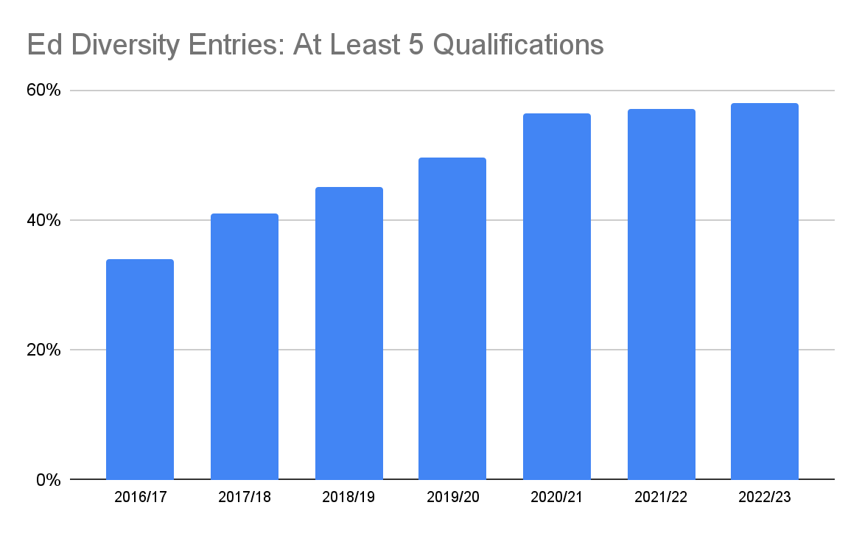

- Key Subject: Students entered for a qualification in English
47 students (94%) were entered for an English qualification. 1 student wasn’t entered via Educational Diversity but sat their exams at their host school.
42 students (84%) achieved a recognised English qualification. This is lower than in 2021/22 when 97.1% of students achieved a recognised English qualification.
Within these, 24 students (48%) were awarded a GCSE grade in English. An increase from 2021/22 when 41.4% achieved a GCSE grade.
40 students (80%) successfully completed a Functional Skills English course. This is lower than for 2021/22 when 95.7% of students gained a FS qualification.
There is no available comparative data for PRUs nationally.

- Key Subject: Students entered for a qualification in Maths
49 students (98%) were entered for a maths qualification with Educational Diversity. The 1 student who wasn’t entered via Educational Diversity sat their exams at their host school.
41 students (82%) achieved a recognised Maths qualification. This is lower than for 2021/22 when 94.3% of students gained a qualification.
Of these, 27 students (54%) were awarded a GCSE grade in maths. This is an increase from 2021/22 when 41.4% of students gained a GCSE grade.
39 students (78%) successfully completed a Functional Skills Maths course. This is lower than 2021/22 when 91.4% of students gained a FS qualification.
2 students (4%) successfully completed the Edexcel Award in Number and Measure. A reduction since 2021/22 when 21.4% of students gained a N&M qualification.
There is no available comparative data for PRUs nationally.

- Key Subjects -Students entered for English and Mathematics GCSEs
25 students (50%) were entered for both English and Maths GCSEs. This is an increase from 2021/22 when 38.6% of students were entered for both GCSE English and maths.
This is inline with the average for Alternative Provision settings nationally 2019/20 (49.3%)
For all schools in England and Wales, 2019/20, this is 97.2%
4. Measures of Attainment
These include:
- students with a single registration at Educational Diversity
- students who were also dual registered at another school, but were actually taught and took exams at Ed Diversity.
This includes a total of 49 students (1 student sat exams at their host school).
- Students gaining at least 1 qualification
Almost every student entered for exams did gain some recognised accreditation.
This means that 43 students (87.8%) left with a recognised qualification. This is slightly lower than for 2021/22 when 97.1% of students gained a qualification.
These include students who were also dual registered at another school, but were actually taught and took exams at Ed Diversity.

- Students gaining 1 or more GCSE grades or equivalents
36 students (73.5%) gained one or more GCSE qualifications or an equivalent Functional Skills grade (level 1 or 2). A slight increase from 2021/22 when 70% of students gained a GCSE or equivalent FS qualification.
These results are above the results in 2019/20 Alternative Provision settings nationally (61%)
For All Schools 2019/20 this is 97.8%.

- Students gaining 5 or more qualifications
29 students (59.2%) left with five or more recognised qualifications. This is a slight increase from 2021/22 when 55.7% of students gained 5 or more qualifications.
Some of these, although valid qualifications, are below GCSE at Entry Level as this was most appropriate to the student's ability. Some students sat more than 1 qualification in maths, English and/or vocational subjects.
There is no readily available national comparison data for AP settings.

- 5+ GCSE or Equivalent
19 students (38.8%) gained five or more qualifications that are either GCSE or the equivalent Functional Skills at Level 1 or Level 2. This is a significant increase from 2021/22 when 21.4% of students gained 5+ GCSE or equivalent grades.

- Higher GCSE Grades - 1+ GCSE Grade 4 or above or equivalent
24 students (49%) gained one or more qualifications at the higher grades that are either GCSE grades 4 -9 or the equivalent at Functional Skills Level 2. This is an increase from 2021/22 when 37.1% of students gained 1+GCSE at 4 or above or equivalent.

- Higher Grades - 5+ GCSE grades 4 -9 or Equivalent
This year, 2 students (4%) left with five higher grades, either in GCSEs or Functional Skills (this included passes for both GCSE maths and FS maths)

- Higher Grades - 5+ GCSE grades 4 -9 or Equivalent and including English and Maths GCSE
The same 2 students (4%) successfully gained five higher grades including English and Maths.

- English Baccalaureate
No students studied subjects to qualify for the EBACC.

- Key Subject: Any Qualification in English
42 students (85.7%) achieved a recognised English qualification, whether GCSE or Functional Skills at their most appropriate level. This is a slight decrease from 2021/22 when 97.1% achieved a qualification.
There is no readily available national comparison data for AP settings.

- Key Subject: Higher Grades in English – Grades 4 -9 or Equivalent
Out of the 26 students entered for a GCSE in English, 3 (6.1%) students gained an English qualification at the higher grades, 4-9.
14 students (28.6%) gained an English qualification at one of the higher grades, whether GCSE 4-9 or Functional Skills Level 2. This is an increase from 2021/22 when 20% gained a GCSE4-9 or a L2 at FS.
Overall 16 students (32.7%) of students gained a higher grade (GCSE or FS Level 2)

These results are in line with the Alternative Provision settings for England and Wales 2019/20 (30%)
For all schools (UK) 2021 the figure was 73.9%

- Key Subject: Any Qualification in Maths
41 students (83.7%) achieved a recognised Maths qualification, at GCSE or Functional Skills at their most appropriate level. This is a decrease from 2021/22 when 94.3% of students gained a maths qualification.
There is no readily available national comparison data for AP settings.

- Key Subject: Higher Grades in Maths – Grades 4 -9 or Equivalent
Out of the 30 students entered for a GCSE in Maths, 9 students (30%) gained a maths qualification at the higher grades, 4-9. This is a slight increase from 2021/22 when 26.7% of students entered for GCSE maths gained 4-9 grades.
12 students (24.5%) gained a Maths qualification at one of the higher grades, whether GCSE 4-9, Functional Skills Level 2 or Number & Measure Level 2. This is an increase from 2021/22 when 17.1% of students gained a GCSE 4-9 or L2 FS qualification.
These results are slightly higher than the results for Alternative Provision settings nationally 2019/20 of 28.6%.
For all schools (UK) 2021 the figure is 69.4%

- Key Subjects: GCSE grades 1-9 or Equivalent in Both English and Maths
28 students (57.1%) gained a grade in both key subjects. A slight increase from 2021/22 when 52.9% of students gained both key subjects at GCSE 1-9 or FS Level 1 or 2.
For many students, the equivalent Level 1 or Level 2 Functional Skills qualifications was more appropriate than GCSE.

- Key Subjects: Higher grades in English and Maths – GCSE grades 4-9 or equivalent.
8 students (16.3%) achieved Higher grades (GCSE 4-9 or FS level 2) in both English and maths. This is an increase from 2021/23 when 7.1% of students achieved higher grades.
This is above the average for Alternative Provision settings nationally 2019/20 (10.3%).
For All Schools in England and Wales this is 71.2%.
5. Comparison of 2020, 2021, 2022 and 2023 results

 | 2020  Results | 2021  Results | 2022  Results | 2023  Results
Proportion of students leaving with at least 1 recognised qualification | 99% | 95% | 97.1% | 87.8%
Proportion of students leaving with at least 1 GCSE grade or equivalent | 72% | 68% | 70% | 73.5%
Proportion of students leaving with at least 5 GCSE grades or equivalents | 29% | 21% | 21.4% | 38.8%
Proportion of students leaving with a qualification in English | 90% | 91.8% | 97.1% | 85.7%
Proportion of students who were gaining a higher grade in English 4-9 or equivalent | 22% | 27% | 20% | 32.7%
Proportion of students leaving with a qualification in Maths | 99% | 90.6% | 94.3% | 83.7%
Proportion of students gaining a higher grade in Maths 4-9 or equivalent | 29% | 21.4% | 17.1% | 24.5%

6. Year on Year Trends

 | 2016  Results | 2017  Results | 2018  Results | 2019  Results | 2020  Results | 2021  Results | 2022  Results | 2023  Results
Proportion of students leaving with at least 1 recognised qualification | 97% | 97% | 99% | 99% | 99% | 95% | 97% | 87.8%
Proportion of students leaving with at least 1 GCSE grade or equivalent | 48% | 42% | 72% | 80% | 72% | 68% | 70% | 73.5%
Proportion of students leaving with at least 5 GCSE grades or equivalents | 24% | 28% | 33% | 35% | 29% | 15.5% | 21.4% | 4%
Proportion of students leaving with a qualification in English | 82% | 87% | 93% | 91% | 90% | 91.8% | 97.1% | 85.7%
Proportion of students gaining a higher grade in English – grades 4-9 or equivalent | 6% | 19% | 18% | 25% | 22% | 27% | 20% | 32.7%
Proportion of students leaving with a qualification in Maths | 96% | 95% | 99% | 99% | 99% | 90.6% | 94.3% | 83.7%
Proportion of students gaining a higher grade in Maths – grades 4-9 or equivalent | 13% | 22% | 24% | 30% | 29% | 21.4% | 17.1% | 24.5%

7. External Students
Educational Diversity has previously provided a supportive examination centre for those students who have nowhere else to take exams.
Without this service these students, who are typically facing very challenging personal circumstances, would gain no qualifications at all.
This year the service was not required to support any external students.
Student Characteristics
Students on roll 30/06/23
Gender
Female | 18  1 student sat exam at host school | 36%
Male | 32 | 64%
Total | 50  49 included in results below

Whole School Headlines | Number | Percentage
Entered for 1+ Quals (any) | 49 students | (100%)
Gained 1+ Quals (Any) | 43 students | (87.8%)
Gained 5+ Quals (any) | 29 students | (59.2%)
Gained 5+ GCSE Equivalents (L1/L2) | 2 students | 4%
Entered for an English Qual | 47 students | (94%)
Gained an English Qual (any) | 42 Students | 85.7%
Gained an English Higher Grade (4+/L2)) | 16 students | (32.7%)
Entered for a maths Qual | 49 Students | 100%
Gained a maths Qual (any) | 41 Students | 83.7%
Gained a maths Higher Grade (4+/L2) | 12 students | (24.5%)
Gained an English and a maths Higher Grade (4+/L2) | 8 students | (16.3%)

 | GCSE Grade Achieved |  |  |  |  |  |  |  | Total Grades
Subject | 1 | 2 | 3 | 4 | 5 | 6 | 7 | 8
English Lang. | 4 | 3 | 14 | 3 |  |  |  |  | 24
English Lit |  |  | 1 |  |  |  |  |  | 1
Maths | 5 | 5 | 8 | 8 | 1 |  |  |  | 27
Biology | 5 | 2 | 8 | 4 |  |  |  |  | 19
Art | 1 | 4 | 7 | 3 | 2 | 1 |  |  | 18
Photography |  | 1 | 4 |  |  |  |  |  | 5
History |  | 1 |  |  |  |  |  |  | 1
Chemistry |  |  | 1 |  |  |  |  |  | 1
Comb Sci |  | 1 | 1 |  |  |  |  |  | 2 (3-2)
Geography |  | 1 |  |  |  |  |  |  | 1
Total | 15 | 18 | 44 | 18 | 3 | 1 |  |  | 99

 | Functional Skills Grade Achieved
Subject | E1 | E2 | E3 | L1 | L2 | Total
English | 0 | 3 | 8 | 14 | 15 | 40
Maths | 0 | 3 | 12 | 14 | 10 | 39
ICT | 0 | 1 | 5 | 5 | 3 | 14
Total | 0 | 7 | 25 | 33 | 28 | 93

Additional exam data 2022/23
Student target/achieved grades
(Year 10 FS results 22/23)

